4 Chivalry Road, London, SW11 1HT
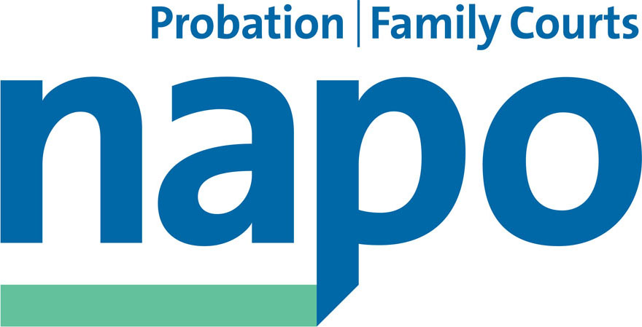

Telephone 020 7223 4887
Fax 020 7223 3503

www.napo.org.uk
Email: info@napo.org.uk

BR97-2015
tbass/mp

The Trade Union Bill – What does it mean for Napo and unions?
The Trade Union Bill has far reaching consequences for all unions and their members. Summarised below are some of the key aspects of the Bill on which we will be issuing more details over the next few weeks.
- Introduction of thresholds for industrial action. Unions will be required to provide a 50% turnout for any industrial action ballots. For some unions within 'key sectors' such as the Fire Brigade Union (FBU), 80% of that turnout will have to vote yes with all abstentions being classed as a 'no' vote.
- Restrictions on pickets will require a “picket supervisor” who’s name will have to be given the police in advance and who will have to carry a letter of authority with them.
- Employers will be able to use agency staff to break industrial action and all employees will have to notify their intention to strike.
- Extension to the role and power of the Certification Officer (CO) will enable them to impose financial penalties to unions and the extra costs of this will be met by the unions themselves effectively making the prisoner pay for their own gaoler!
- Facility time will be capped, even that of Health and Safety reps, and employers in the public sector will have to report on how facility time is allowed. It will reduce the statutory right for paid time off for elected officials and significantly reduce the ability to represent members at work, negotiate terms and conditions and secure access to learning.
- There are also proposals to restrict the use of social media during any industrial action. Unions will have to notify the employer and the Police of any intention to use social media before and during strike action and these postings will be monitored by the police.
- Removal of 'Check Off' facilities (union subscriptions directly from pay) which is designed to disrupt the financial position of unions. This is one of the reasons why Napo has already launched its 'switch to Direct Debit' campaign.
This is a massive attack not just on trade unions themselves but on individual civil liberties. It will deny people the right to protest or to privacy on their social media accounts and restrict the fundamental rights of freedom of speech and association. We must unite to defeat this Bill and a number of events are taking place across the country to raise public awareness
What Can You Do?
Help make a major anti-Bill demonstration a success by attending the
KILL THE BILL LOBBY OF PARLIAMENT 13th October London
- 5pm Demo on Parliament Square
- 6pm Lobby in Parliament Committee room 10
Speakers (so far) include: Mark Serwotka (PCS), Michelle Stanistreet (NUJ), Matt Wrack (FBU), John McDonnell MP (TUCG), Ian Lavery MP (Labour TU Group), Caroline Lucas (Green), Hannah Bardell (SNP), NSSN, Unite The Resistance
Write to your MP: Whatever Party your MP may belong to, they have to respond if they get 5 or more letters on one subject. Why not organise a workplace meeting to consider the implications of the Bill and to arrange to visit your MP as well. Also consider how you can get the local media involved in publishing your views about the threats posed by the TU Bill, and encourage your colleagues to do the same.
Attend the Napo AGM in Eastbourne, where it is likely that at least one Emergency Motion will be submitted for debate. Register via this link: https://www.napo.org.uk/Napo%20Courses%20%26%20Events/agm-2015
Look out for more news from Napo and the TUC about the progress of the bill -and if you wish to discuss any aspects of this circular please contact tbassett@napo.org.uk
At the massive demonstration against Austerity and the Trade Union bill which took place in Manchester yesterday, the message was overwhelmingly clear:
We will have to fight for our right to strike!

Ian Lawrence, General Secretary
Tania Bassett , National Official, Press Parliament and Campaigns

